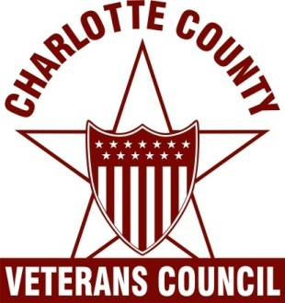

  - Donation Form
Each year, the CCVC gives much-needed assistance to Charlotte County’s needy and homeless veterans and the Florence Ryan Fund is sustained by generous donations such as yours.

Florence L. Ryan chose to honor veterans in a unique and special way. It is the goal of the Council and its Executive Committee to ensure her wishes are honored as outlined in her will.

Date_____________

Name: _________________________________________________________

Donation amount: __________________________________________

Notes: _____________________________________________________

______________________________________________________

Please mail donations to:
Charlotte County Veterans Council
P.O. Box 380964
Port Charlotte, FL 33938-0964

